**Software to be installed:**

1. java 8
2. Apache Ignite 2.7.5
3. Oracle 12c
4. Python 3.6

Note: Node JS dependent libraries are already bundled with the JAR.

## Java Setup:

1. Check whether OS architecture is 32-bit or 64-bit with the command

file /sbin/init

1. Browse & navigate to the website, <https://www.oracle.com/java/technologies/javase-jre8-downloads.html> and pick the java file depending on the architecture. You can also download from the terminal using this:

wget <https://www.oracle.com/java/technologies/javase-jre8-downloads.html#license-lightbox>

1. Select the suitable file and right click and copy the link address and then paste it in place of the above link (after wget)
2. Navigate to the location of your zip file. Extract contents of java zip file in a directory of your choice.

eg: sudo tar -xvf jre-8-linux-i586.tar.gz

1. Use this command to extract
2. We have to let Linux know where our JRE is located. Use the commands below:

sudo update-alternatives --install "/usr/bin/java" "java" "path to your jre/bin/java" 1

1. Installation must be the default Java. Use below commands to do this:

sudo update-alternatives --set java <Directory where JAVA has been extracted>/bin/java

1. Test the installation using this command:

java -version

## Python installation:

1. Download prerequisites for python:
2. sudo yum -y update
3. sudo yum -y install yum-utils
4. install development tools to build and compile software from source code
5. sudo yum -y groupinstall development
6. Download python 3.6 using this command:
   1. sudo yum -y install python36
7. install pip
   1. sudo yum -y install python36-pip
8. setting python path:
   1. Open the file ~/.bashrc in your text editor using the command:
   2. vi .bashrc
9. Add the following line to the end:
   1. export PYTHONPATH=path where python is installed (eg:/home/my_user/code.):$PYTHONPATH
10. Save the file. press (esc+w+q)
11. Close your terminal application.
12. Start your terminal application again, to read in the new settings, and type this: echo $PYTHONPATH
13. Should show something like /home/my_user/code.
14. Check if the installation is successful:
    1. python3 -V
15. To manage software packages for Python, pip is used, a tool that will install and manage programming packages we may want to use in our development.
16. install the dependencies below:
    1. pip install cx_Oracle
    2. pip install httplib2
    3. pip install json
    4. pip install pickle
    5. pip install numpy
    6. pip install Flask
    7. pip install pandas
    8. pip install configparser
    9. pip install jsonlib
    10. pip install pickle-mixin
    11. pip install pyomo
17. <https://ampl.com/products/solvers/open-source/> download CBC using this link. If you need to download using terminal then use: wget <https://ampl.com/dl/open/cbc/cbc-linux64.zip>
18. Select the link specific to the system architecture

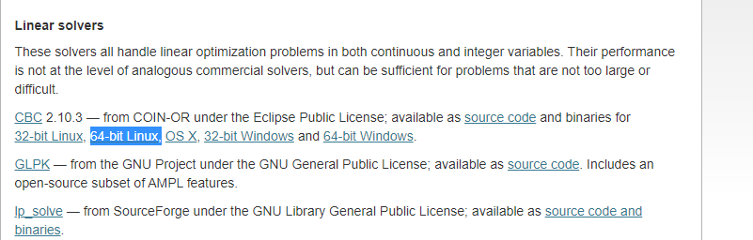

In the screenshot above, there are links for different architectures. Right click “copy link address”, go to the terminal, type wget, space, paste the link address you just copied and hit ENTER. The download will start. Add this path also to the bashrc file in the same way that we did while setting the path for python.

“export CBCPATH=path where CBC is installed (eg:/home/my_user/code.):$CBCPATH”

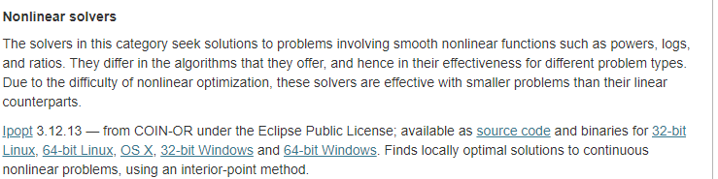

The screenshot above shows the links for different architectures, click on the appropriate link and the download will start.

Add the folder path to the environment variable.

## Ignite setup:

1. Download the binary file using this command:
2. wget <https://archive.apache.org/dist/ignite/2.7.5/apache-ignite-2.7.5-bin.zip>
3. To check if ignite is successfully installed, we need to start the cache.
4. The steps to start the cache are:
5. Navigate to the ignite folder and start cache with the command: bash bin/ignite.sh
6. A message “Ignite node started OK”.
7. Pls find the screenshot below on next page:

